|  |  |
| --- | --- |
| **Content Type** | **Tutorial** |
| **Title** | **Lesson 5.4 - What’s the Difficulty?** |
| **Summary** | **Overview:**  It’s time for the final lesson! To finish our game, we will add a Menu and Title Screen of sorts. You will create your own title, and style the text to make it look nice. You will create three new buttons that set the difficulty of the game. The higher the difficulty, the faster the targets spawn!  **Project Outcome:**  Starting the game will open to a beautiful menu, with the title displayed prominently and three difficulty buttons resting at the bottom of the screen. Each difficulty will affect the spawn rate of the targets, increasing the skill required to stop “good” targets from falling. |
| **Overview Video** |  |
| **Cover Image** |  |
| **Unity Version** | 2018.4 - 2020.3 |
| **Difficulty Level** | Beginner |
| **Estimated Time** | 1h 00min |
| **Skills** | Write code that utilizes the various Unity APIs  Write code that integrates into an existing system |
| **XP Categories and Values** | Programming - 10 xp |
| **Unity editor packages** | - |
| **Tags** | - |
| **Topics** | For Educators  Scripting  User Interface |
| **Industries** | - |
| **Video transcripts** | - |
| **Files and assets** | - |
| **Unity docs links** | - |
| **Asset store links** | - |
| **Learn group link** | - |
| **Hidden / Visible** | Hidden |

## Step 1: Create Title text and menu buttons

*The first thing we should do is create all of the UI elements we’re going to need. This includes a big title, as well as three difficulty buttons.*

1. Duplicate your **Game Over text** to create your **Title Text,** editing its name, text and all of its attributes
2. Duplicate your **Restart Button** and edit its attributes to create an “Easy Button” button
3. Edit and duplicate the new Easy **button** to create a“Medium Button” and a “Hard Button”

## Step 2: Add a DifficultyButton script

*Our difficulty buttons look great, but they don’t actually do anything. If they’re going to have custom functionality, we first need to give them a new script.*

1. For all 3 new buttons, in the Button component, in the **On Click ()** section, click the **minus** (**-**) button to remove the RestartGame functionality
2. Create a new **DifficultyButton.cs** script and attach it to **all 3 buttons**
3. Add ***using UnityEngine.UI*** to your imports
4. Create a new ***private Button button;*** variable and initialize it in ***Start()***

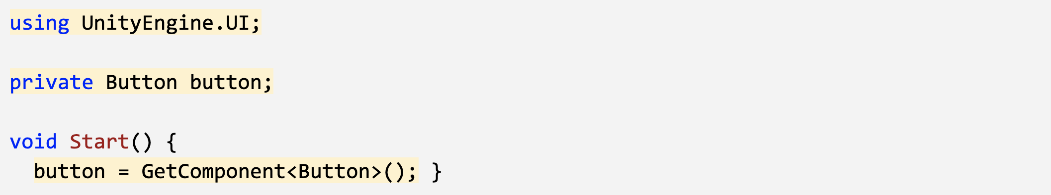

## Step 3: Call SetDifficulty on button click

*Now that we have a script for our buttons, we can create a SetDifficulty method and tie that method to the click of those buttons*

1. Create a new ***void SetDifficulty*** function, and inside it, ***Debug.Log(gameObject.name + " was clicked");***
2. Add the **button listener** to call the ***SetDifficulty*** function

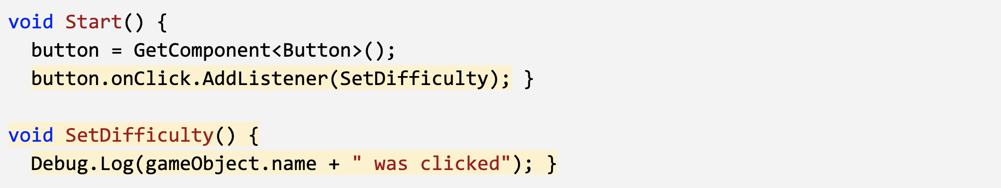

## Step 4: Make your buttons start the game

*The Title Screen looks great if you ignore the target objects bouncing around, but we have no way of actually starting the game. We need a StartGame function that can communicate with SetDifficulty.*

***CwC 5.4.4 Make your buttons start the game***

1. In GameManager.cs, create a new ***public void StartGame()*** function and move everything from ***Start()*** into it
2. In DifficultyButton.cs, create a new ***private GameManager gameManager;*** and initialize it in ***Start()***
3. *In the* ***SetDifficulty()*** *function, call* ***gameManager.StartGame();***

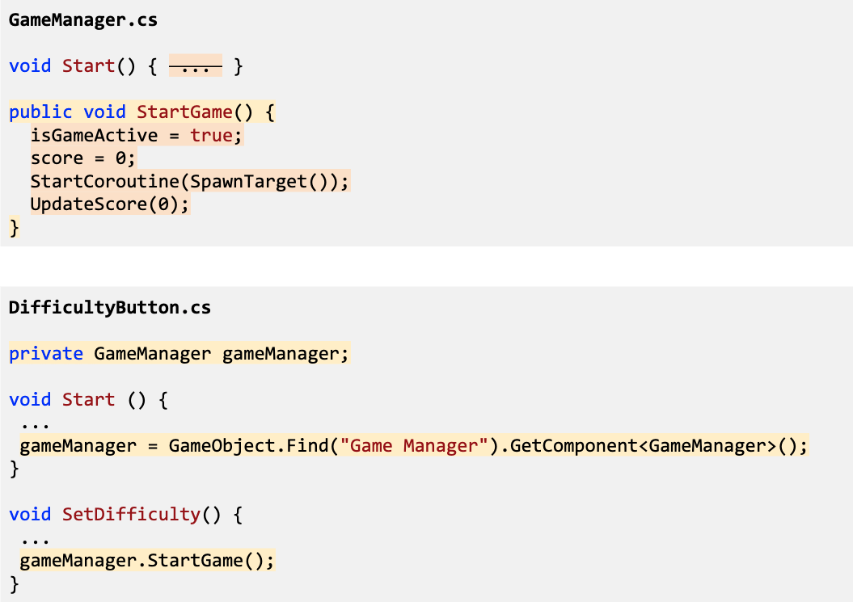

## Step 5: Deactivate Title Screen on StartGame

*If we want the title screen to disappear when the game starts, we should store them in an empty object rather than turning them off individually. Simply deactivating the single empty parent object makes for a lot less work.*

1. Right-click on the Canvas and *Create > Empty Object*, rename it “Title Screen”, and drag the **3 buttons** and **title** onto it
2. In GameManager.cs, create a new ***public GameObject titleScreen;*** and assign it in the inspector
3. In ***StartGame()***, deactivate the title screen object

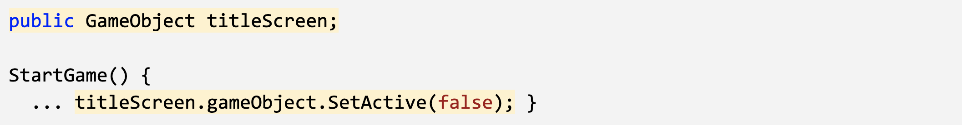

## Step 6: Use a parameter to change difficulty

*The difficulty buttons start the game, but they still don’t change the game’s difficulty. The last thing we have to do is actually make the difficulty buttons affect the rate that target objects spawn.*

1. In DifficultyButton.cs, create a new ***public int difficulty*** variable, then in the Inspector, assign the **Easy** difficulty as 1, **Medium** as 2, and **Hard** as 3
2. Add an ***int difficulty*** parameter to the ***StartGame()*** function
3. In ***StartGame()***, set ***spawnRate /= difficulty;***
4. Fix the error in DifficultyButton.cs by passing the difficulty parameter to ***StartGame(difficulty)***

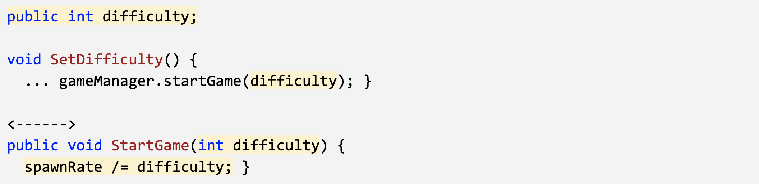

## Step 7: Lesson Recap

New Functionality

* Title screen that lets the user start the game
* Difficulty selection that affects spawn rate

New Concepts and Skills:

* AddListener()
* Passing parameters between scripts
* Divide/Assign (/=) operator
* Grouping child objects